Themes
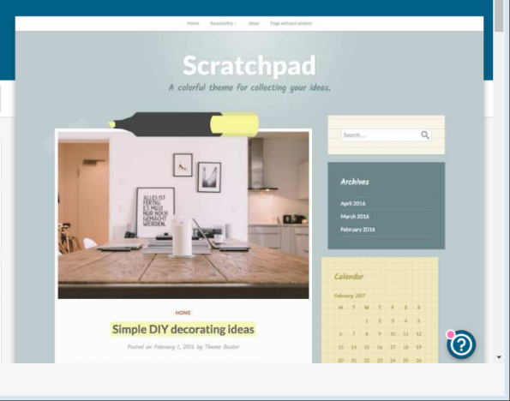

This is an example of a theme which I might use for my website design. This drawn attention to me because it’s very neat and readable. When I create my website I would like it to look tidy and presentable. I like the pastel colours which they’ve used in this and how bright and colourful it looks. It’s not too outstanding which is the look that I like with these websites.

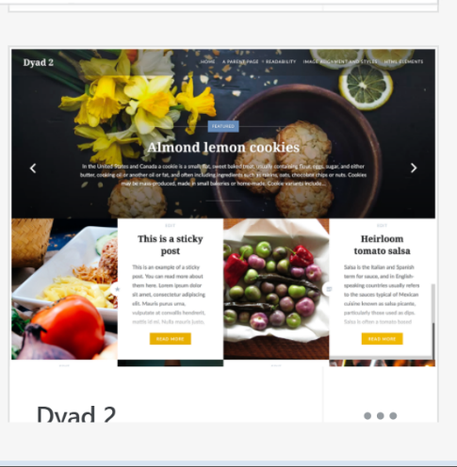

This is another theme which caught my eye. This is full of good information which really promotes whatever they’re selling. I like the colours which are used and the background looks good, because it’s showing their products.

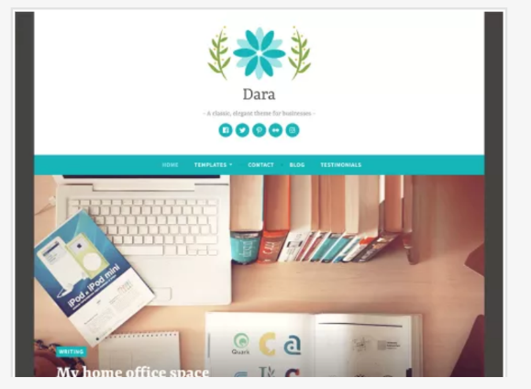
I like how simple it looks. If I went on this website I think it’ll be really easy to use and to get onto. I like the light blue against the white because I think it stands out a lot more.
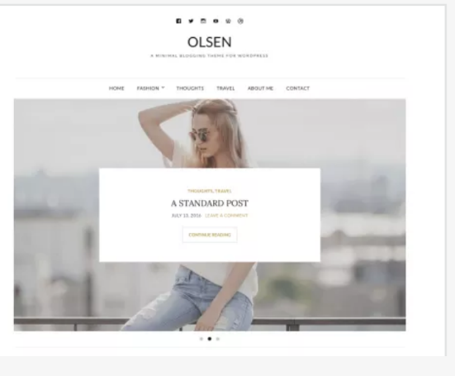

I also love the look of this one because of the photo in the middle of the page. It makes it stand out a lot more and makes it very eye catching. The font at the top is very readable which is even better for the company.

